CTE: Career & Technical Education
Business & Marketing – Foods & Hospitality – Nursing & Allied Health

ALL CTE COURSES – STUDENT ENRICHMENT
SUGGESTED TIME COMMITMENT for STUDENT ENRICHMENT
It is the recommendation of the CTE teaching staff, that students enrolled in any CTE class spend 30-45 minutes each day, per course on content enrichment activities. The following content includes recommendations for all courses as well as individual teacher recommendations and class content information.

CAREER CRUISING
All WWT students have a Career Cruising account.
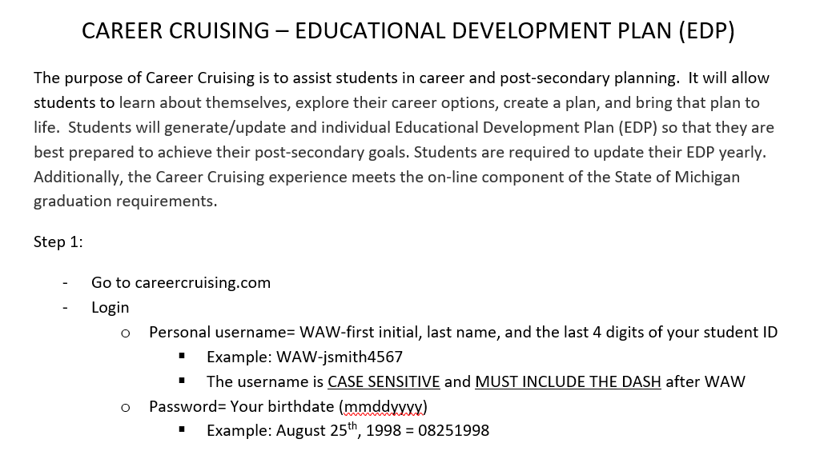

For additional assistance with Career Cruising login, email Diana Rende at drende@mywwps.org.
MRS. GHATTAS’ INFO
SCHOOLOGY
All of Mrs. Ghattas’ classes are already using Schoology. All students should already have their account information.

ENRICHMENT WEBSITES & ACTIVITIES
KHAN ACADEMY (for Marketing & Business content) https://www.khanacademy.org/search?referer=%2F&page_search_query=marketing

REMIND101 CODES
REMIND: Marketing 1st, 3rd, and 6th hours: @aagh3k
REMIND: Accounting: @aa9kfg
REMIND: Marketing 2/Store Management: @makret

EMAIL
aghattas@mywwps.org

MRS. ADAMS’ INFO
SCHOOLOGY
All of Mrs. Adams’ classes have been to added to Schoology. Mrs. Adams will begin using Schoology in the upcoming weeks.

ENRICHMENT WEBSITES & ACTIVITIES
Culinary Arts CTE Online Model: https://www.cteonline.org/curriculum/outline/culinary-arts-cte-online-model/eC6wVA
NETFLIX: Rotten Rotten is an American television show produced by Zero Point Zero. It focuses on problems in the process of supplying food: https://www.netflix.com/watch/80232019?trackId=13752289&tctx=0%2C1%2C735cdc7f-c418-44f1-b9df-39bd5d49cc4f-1065824389%2C%2C
YOUTUBE: How to Master 5 Basic Cooking Skills – Gordon Ramsey: https://www.youtube.com/watch?v=ZJy1ajvMU1k
INTERACTIVE GAME: Crazy Games – Restaurant: https://www.crazygames.com/search?q=restaurant
YOUTUBE: Master Chef Junior – Season 5: https://www.youtube.com/watch?v=GzPBJFN_Rn8&list=PLB8hMWIc6bCfk8WnZDc_iP9YWP5Ea4fK6&index=1

REMIND101 CODES
REMIND: Foods I – Adams: @283fb6
REMIND: Foods II – Adams: @adk9dc
REMIND: Foods III/Foods IV – Adams: @foodsiiia

EMAIL
sadams@mywwps.org

MS. MURRAY’S INFO
SCHOOLOGY
All of Ms. Murray’s classes have been to added to Schoology. Ms. Murray will begin using Schoology in the upcoming weeks.

ENRICHMENT WEBSITES & ACTIVITIES
Culinary Arts CTE Online Model: https://www.cteonline.org/curriculum/outline/culinary-arts-cte-online-model/eC6wVA
NETFLIX: Rotten Rotten is an American television show produced by Zero Point Zero. It focuses on problems in the process of supplying food: https://www.netflix.com/watch/80232019?trackId=13752289&tctx=0%2C1%2C735cdc7f-c418-44f1-b9df-39bd5d49cc4f-1065824389%2C%2C
YOUTUBE: How to Master 5 Basic Cooking Skills – Gordon Ramsey: https://www.youtube.com/watch?v=ZJy1ajvMU1k
INTERACTIVE GAME: Crazy Games – Restaurant: https://www.crazygames.com/search?q=restaurant
YOUTUBE: Master Chef Junior – Season 5: https://www.youtube.com/watch?v=GzPBJFN_Rn8&list=PLB8hMWIc6bCfk8WnZDc_iP9YWP5Ea4fK6&index=1

REMIND101 CODES
REMIND: Foods I – Murray: @k6heb8
REMIND: Foods II – Murray: @b3c27k
REMIND: Foods III – Murray: @d4a6ek
REMIND: Foods IV – Murray: @6774be

EMAIL
smurray@mywwps.org

MRS.VANHUYSSE’S INFO
SCHOOLOGY
All of Mrs. VanHuysse’s classes are already using Schoology. All students should already have their account information.

ENRICHMENT WEBSITES & ACTIVITIES
KHAN ACADEMY (for Nursing Assistant content): https://www.khanacademy.org/search?page_search_query=Nursing
Course 1: Health Care Systems: Lesson – Health Care System Overview: https://www.khanacademy.org/science/health-and-medicine#infectious-diseases
Course 2: Miscellaneous: Lesson – Inflammation: https://www.khanacademy.org/science/health-and-medicine/healthcare-misc-unit/healthcare-misc/v/inflammation
Course 3: Current Events in Health and medicine: Lesson – Antibiotics and Antibiotic Resistance: https://www.khanacademy.org/science/health-and-medicine/current-issues-in-health-and-medicine/antibiotics-and-antibiotic-resistance/a/antibiotics-an-overview
Course 4: Infectious Diseases: Lesson – Tuberculosis: https://www.khanacademy.org/science/health-and-medicine/infectious-diseases#tuberculosis
Lesson – Pertussis: https://www.khanacademy.org/science/health-and-medicine/infectious-diseases/pertussis/v/what-is-pertussis
Lesson – Influenza: https://www.khanacademy.org/science/health-and-medicine/infectious-diseases#influenza
Lesson – Sexually transmitted diseases: https://www.khanacademy.org/science/health-and-medicine/infectious-diseases/sexually-transmitted-diseases/a/what-are-sexually-transmitted-diseases
Lesson – HIV and AIDS: https://www.khanacademy.org/science/health-and-medicine/infectious-diseases/hiv-and-aids/a/what-is-hivaids
NURSING ASSISTANT SKILLS VIDEOS: https://4yourcna.com/cna-skills-videos/
NURSING ASSISTANT ANIMATED LESSONS: https://4yourcna.com/animated-lessons/
NURSING ASSISTANT PRACTICE QUESTIONS: https://4yourcna.com/practice-questions/
REMIND101 CODES
REMIND: 1st Hour MA - CTE: @ma1sh
REMIND: 2nd Hour: A&P: @2h7637
REMIND: 3rd Hour: MA – Hybrid: @ma3r
REMIND: 4th Hour: A&P – Hybrid: @8fd83d
REMIND: 5th Hour: Baker EMC – LMC = CANVAS
REMIND: 6th Hour: A&P – Hybrid: @49622ad

EMAIL mvanhuysse@mywwps.org
MRS.KAUSCH’S INFO
SCHOOLOGY
All of Mrs. Kausch’s classes have been to added to Schoology. Mrs. Kausch will begin using Schoology in the upcoming weeks.

ENRICHMENT WEBSITES & ACTIVITIES
KHAN ACADEMY (for Nursing Assistant content): https://www.khanacademy.org/search?page_search_query=Nursing
Course 1: Health Care Systems: Lesson – Health Care System Overview: https://www.khanacademy.org/science/health-and-medicine#infectious-diseases
Course 2: Miscellaneous: Lesson – Inflammation: https://www.khanacademy.org/science/health-and-medicine/healthcare-misc-unit/healthcare-misc/v/inflammation
Course 3: Current Events in Health and medicine: Lesson – Antibiotics and Antibiotic Resistance: https://www.khanacademy.org/science/health-and-medicine/current-issues-in-health-and-medicine/antibiotics-and-antibiotic-resistance/a/antibiotics-an-overview
Course 4: Infectious Diseases: Lesson – Tuberculosis: https://www.khanacademy.org/science/health-and-medicine/infectious-diseases#tuberculosis
Lesson – Pertussis: https://www.khanacademy.org/science/health-and-medicine/infectious-diseases/pertussis/v/what-is-pertussis
Lesson – Influenza: https://www.khanacademy.org/science/health-and-medicine/infectious-diseases#influenza
Lesson – Sexually transmitted diseases: https://www.khanacademy.org/science/health-and-medicine/infectious-diseases/sexually-transmitted-diseases/a/what-are-sexually-transmitted-diseases
Lesson – HIV and AIDS: https://www.khanacademy.org/science/health-and-medicine/infectious-diseases/hiv-and-aids/a/what-is-hivaids
NURSING ASSISTANT SKILLS VIDEOS: https://4yourcna.com/cna-skills-videos/
NURSING ASSISTANT ANIMATED LESSONS: https://4yourcna.com/animated-lessons/
NURSING ASSISTANT PRACTICE QUESTIONS: https://4yourcna.com/practice-questions/

REMIND101 CODES
REMIND: Nursing Assistant: @22dedb
REMIND: Medical Assistant: @cahdk7
EMAIL
jkausch@mywwps.org

