Warren Woods Public Schools Open House & kindergarten Round-Up  Join the WWPS Family  Warren Woods Public Schools is excited to invite you and your child to learn more about our caring, safe, and dynamic programs and how it can benefit you and your child.  Meet our faculty, see our classrooms, submit enrollment materials, and discuss what it is like to be a part of the Warren Woods community. All parents of Fall 2019 kindergarten are encouraged to attend.  Come learn more about our Elementary Program  Wednesday, February 13th  6:00-7:30 p.m.  WWPS Administrative Services Center  12900 Frazho Road, Warren, Michigan 48089  This program is for our community to learn more about our K-5 elementary programs. You will also learn about the registration process and what materials you will need to gather and provide upon registration.  *Free Childcare Provided  Please do not hesitate to call prior to the event if you have questions or concerns about your ability to provide the documentation listed above, please call 586.439.4468 or 586.439.4443 | 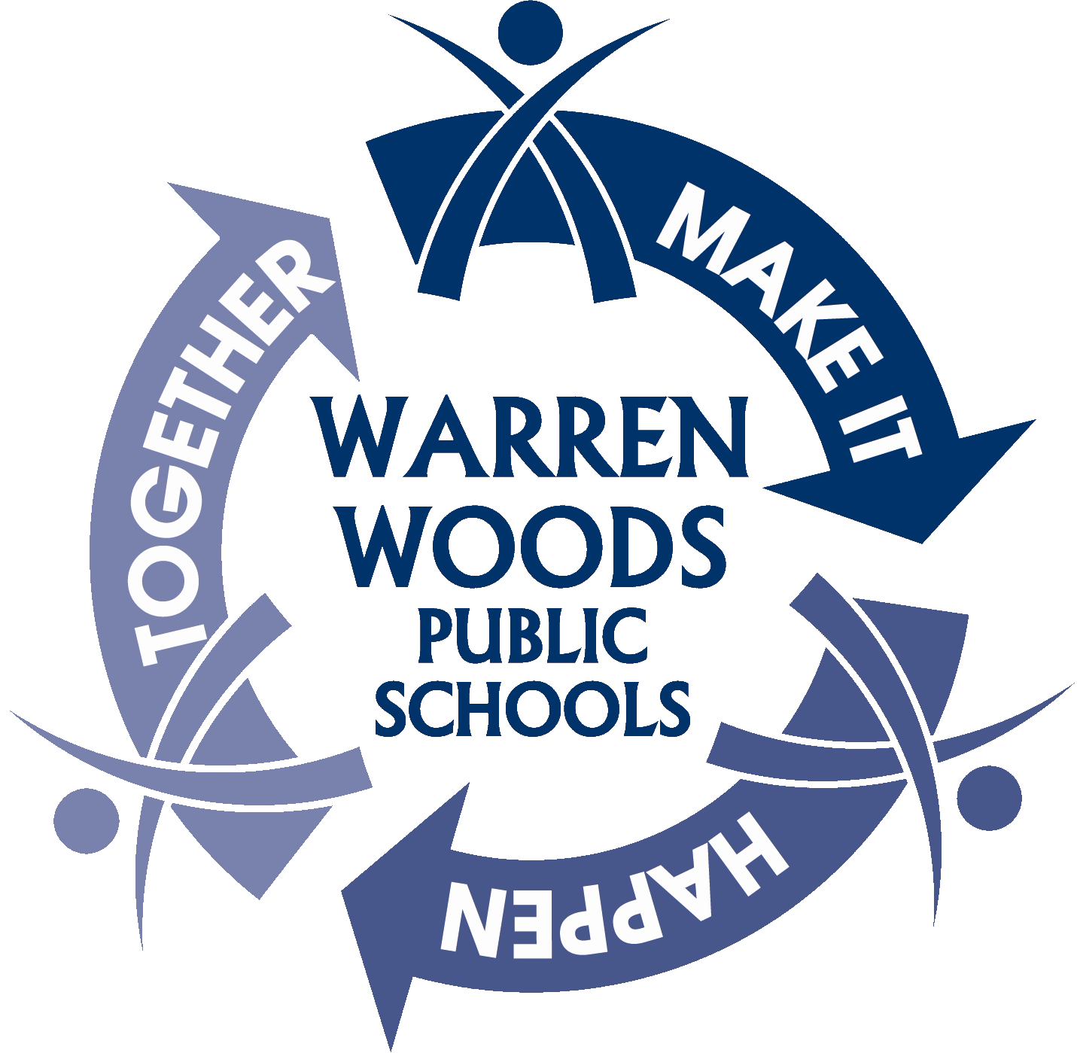  kindergarten Round up events  Briarwood Elementary School  March 5th  5:30 -7:30 p.m.  14100 Leisure Dr.  586.439.4404  Pinewood Elementary School  March 6th  5:30 -7:30 p.m.  14411 Bade Ave.  586.439.4405  Westwood Elementary School  March 7th  5:30 -7:30 p.m.  11999 Martin Rd.  586.439.4406  The registration process takes about 45 minutes to an hour to complete. Tours of the building will offered throughout the event.  www.warrenwoods.misd.net

